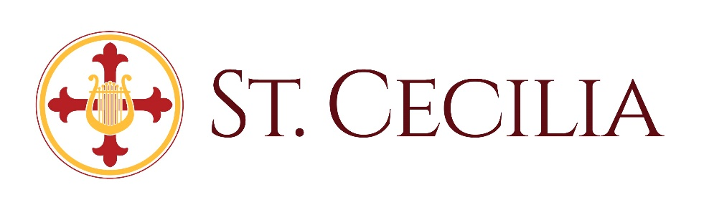
Cemetery Monument & Columbarium Guidelines
Monuments:
- Stone Monuments and their foundations are the responsibility of the Funeral Home who is providing the funeral services unless, other arrangements are made with the St. Cecilia Cemetery Committee.
- “Monument” shall include grave monuments, markers, and slabs.
- A monument is not required on a purchased plot prior to internment but is required within 2 years after internment. Sufficient time should be allowed for the plot to settle after internment, about one year.
- All monuments shall be installed on top of a concrete foundation the same size as or smaller than the bottom stone of the monument. The monument shall be at least 24” in depth, and the highest point shall be no higher than the lowest point of the ground. All wood framing shall be removed from the foundation prior to setting the monument. This work shall be completed by a reputable and bonded contractor familiar with this type of work, preferably the company installing the monument.
- All monuments shall be installed in line with other monuments and completely on the plot. Any questions about the proper location shall be brought to the St. Cecilia Cemetery Committee.
- All joints must be sealed with permanent material to exclude moisture and frost.
- Military markers shall be placed at the foot of the grave unless it’s the primary marker, or if it’s attached to the stone monument. Unless it’s attached to the monument, the military marker shall be mounted on a foundation as described above. The top of the marker shall be flush with the ground.
- Any flat monuments or markers shall be installed flush with the ground.
- Plants, rocks, benches, and other objects, other than the monuments and markers, are prohibited.
Columbarium:
- The Columbarium Door opening, closing, and engraving are the responsibility of the Funeral Home who is providing the funeral services, unless other arrangements are made with the St. Cecilia Cemetery Committee.
- The Door shall be engraved within 30 days of inurnment with same font, size, and information (name and dates) as previously engraved Doors. The engraving shall be completed by a reputable and bonded contractor.
- Decorations, flowers, or other items placed on or affixed to the Columbarium structure are prohibited. Floral arrangements, objects, written notes, memorial cards, photographs, or decorations of any type, shall be regularly removed by the Cemetery Maintenance staff to maintain the safety and appearance of the Columbarium area.
- Only the human cremated remains of the niche owner, per cemetery records, shall be placed in the Columbarium niche. Remains shall be contained in a suitable urn. Other use of the Columbarium niche is strictly prohibited.

