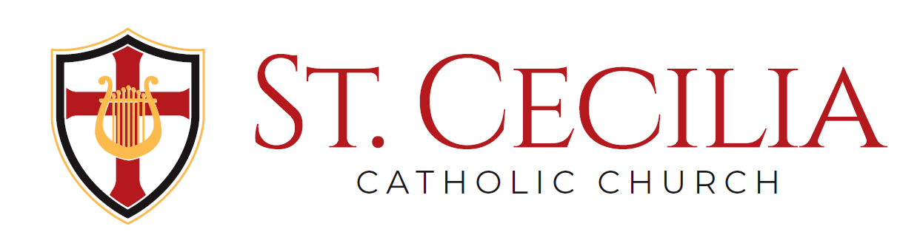
church hall rentals

Large Events (Up to 400 people) $1200 (Parishioners) $1500 (Non-Parishioners)
(Includes all wedding receptions and formal evening events.)

Medium Size Events (Up to 150 people) $600 (Parishioners) $1000 (Non-Parishioners)
(Examples include showers, anniversary celebrations and class reunions.)

Smaller Events (Up to 50 People) $100 (Parishioners) $150 (Non-Parishioners)
(Examples include birthday parties and family events. Renter responsible for clean-up.)

**Events over 4 hours in duration** $75/hour (Parishioners) $100/hour (Non-Parishioners)

All Large and Medium Size events require a 50% deposit to finalize reservation. Smaller Events require payment in full.

Additional Fees

Hall Manager Fee $300
(Required for all large and medium size events. Includes coordinating event, assisting caterers and DJ’s, monitoring event, plus set-up and cleanup.)

Bartenders $100 each
(For medium size events, two bartenders recommended. More than 250 people would require three bartenders. For any event that runs over 4 hours, each bartender receives an additional $25 per hour.)

Table Linens $7 per table
(Tables seat eight. Covers available in black, white, red & champagne. Any over-sized linens or table skirts will be at an additional cost.)

Consumables
Beer (Draft-Domestic Half-Barrel) $145 each
(Large parties will typically require multiple half-barrels for an event.)

Beer (canned) $21 per case
(Craft or specialty beer available at additional cost by request.)

Soft Drinks $3.75 per pound of syrup
(Large parties would typically consume from 35-50 pounds for an event.)

Regular Potato Chips $6 per 8 lb. bag
BBQ Potato Chips $8 per 8 lb. bag
Pretzels $8 per 8 lb. bag

One Day Alcohol/Wine license (required if liquor is served) $266.66
Both state ($100.00) and City of Independence ($166.66) license required.

**All prices are subject to change. State income tax where applicable.

